15 Guidance on Playful Evaluation

Introduction
This guide aims to help you review how your playful redesign worked, and where it could be even better! It uses a three-stage reflective cycle, adapted from Kolb's (1982) experiential learning model. In Kolb’s model, the first stage (Concrete Experience) was your playful session itself. This framework begins after that experience, and guides you through these three stages:
- Reflective Observation - What did I notice?
- Abstract Conceptualisation - What sense do I make of it?
- Active Experimentation - What will I do differently?
At each stage, questions are organised across four domains:
- Affective (engagement and motivation),
- Cognitive (understanding and meaning-making),
- Sensorimotor (bodies, space, and materials), and
- Social-Inclusive (participation and collaboration).
The Playful Evaluation Model diagram (Figure 1) provides an overview of the framework.

Figure 1: A reflective model for evaluating your playful learning
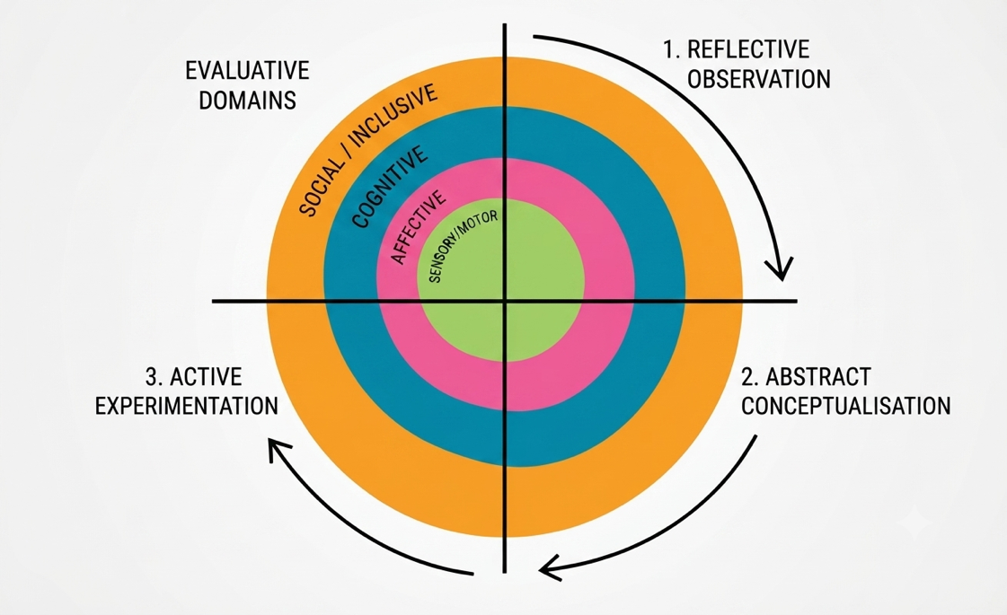
In the interactive questions that follow, questions are also divided into two modes, following Donald Schön's distinction between reflecting-in-action (thoughts and adjustments during delivery) and reflecting-on-action (deeper thinking after delivery). This helps capture both immediate responses and considered analysis.
Stage 1: Reflective Observation (what did I notice?) | AFFECTIVE DOMAIN | During delivery (reflecting-in-action)  - When do you notice the activity levels in the room change? [what worked well?]  - Are students genuinely absorbed – if so, how?  - What moments make you want to adjust your approach mid-session? | After delivery (reflecting-on-action)  - Where was the flow lost - and what might have disrupted it?  - When did students seem most drawn into the activity (rather than just compliant)?  - Were there moments of resistance or hesitation? What happened just before them?
Stage 1: Reflective Observation (what did I notice?) | COGNITIVE DOMAIN | During delivery (reflecting-in-action)  - When do students make connections - to prior knowledge, to each other's ideas, to the world beyond the classroom?  - When do you see students initiate learning activities?  - At what point did the thinking seem to deepen or change?  - Where did confusion arise? What were students doing or saying when it happened? | After delivery (reflecting-on-action)  - When did students display the highest level of thinking? (e.g. reflection, evaluative thinking) - what was happening at that moment?  - Which concepts seemed to make sense through the playful activity - and which remained abstract or distant?  - Were there moments of unexpected insight - ideas emerging that you hadn't anticipated?
Stage 1: Reflective Observation (what did I notice?) | SENSORY-MOTOR DOMAIN | During delivery (reflecting-in-action)  - How are students using their bodies and the space? What did their physical engagement tell you?  - When do the materials or objects become central to the learning, rather than incidental?  - Do you notice any friction between the space and what you were trying to achieve? | After delivery (reflecting-on-action)  - Were students physically active or mostly sedentary? Did this matter for the learning?  - Were there differences between use of the space and movement in this session and previous (non-playful) sessions?  - How did the use of space, movement, or materials shape participation?  - Did students develop or practice any practical, hands-on skills through the activity?
Stage 1: Reflective Observation (what did I notice?) | SOCIAL-INCLUSIVE DOMAIN | During delivery (reflecting-in-action)  - What different modes of participation do you notice - vocal, physical, observational, supportive?  - Who is engaging visibly? Who might be engaging in less obvious ways?  - Do you notice any students struggling to access the activity - or choosing to engage differently than you expect? | After delivery (reflecting-on-action)  - What did participation look like - and how might the design have shaped these?  - Were quieter students disengaged, or participating in ways less immediately visible?  - What evidence do you have either way?  - Did the activity favour certain modes of participation over others? Was this intentional?

Stage 2: Abstract Conceptualisation (What sense do I make of it?) | AFFECTIVE DOMAIN | During delivery (reflecting-in-action)  - What sense are you making, in the moment, of energy shifts you notice?  - When you step in or adjust, what are you responding to? | After delivery (reflecting-on-action)  - What aspect of the session engaged students' own motivation - and why do you think it worked?  - What might explain the moments where flow was disrupted?  - Did the session include, encourage and support risk and failure? Did this change engagement?
 | COGNITIVE DOMAIN | During delivery (reflecting-in-action)  - When do you notice confusion or breakthrough?  - What connections are you noticing between the playful activity and the learning? | After delivery (reflecting-on-action)  - Where did the playful approach help understanding? Where might it have distracted?  - When did the most appropriate thinking happen and why?
 | SENSORY-MOTOR DOMAIN | During delivery (reflecting-in-action)  - What adjustments do you make to space, materials, or physical arrangement - and why?  - When do the physical, hands-on dimension feel essential to the learning? | After delivery (reflecting-on-action)  - To what extent did making, handling, or moving contribute to students' understanding ...and how?
 | SOCIAL-INCLUSIVE DOMAIN | During delivery (reflecting-in-action)  - What do you notice about the ways that students are working together or not?  - Do you notice unequal participation or exclusion? | After delivery (reflecting-on-action)  - Which aspects may have created barriers or inequities in participation?  - What enabled collaboration to be productive where it worked? What undermined it where it didn't?  - How did the activity shape who could contribute and in what ways?

Stage 3: Active Experimentation (What will I do differently?) | AFFECTIVE DOMAIN | During delivery (reflecting-in-action)  - What adjustments do you make to sustain engagement or recover momentum?  - How do you respond when you sense students are disengaging or becoming anxious? | After delivery (reflecting-on-action)  - How could you change the activity to better support a sense of safety and productive failure?  - What changes might help students stay immersed for longer, or engage more willingly?  - If you ran this again, what would you do differently to sustain motivation?
 | COGNITIVE DOMAIN | During delivery (reflecting-in-action)  - What changes do you make to help students grasp the concepts? Why?  - How did you respond when you noticed confusion or misconceptions emerging? | After delivery (reflecting-on-action)  - How could you change the instructions or play prompt to help students engage more readily?  - What support might help students move from playful experimenting to identifying key ideas?  - Which elements would you keep, change, or remove to strengthen the learning?
 | SENSORY-MOTOR DOMAIN | During delivery (reflecting-in-action)  - What physical or material adjustments do you make during the session?  - How do you adapt the use of space or resources in response to what was happening? | After delivery (reflecting-on-action)  - What changes to space, materials, or physical setup might improve the activity?  - Could different or additional resources support the hands-on aspect of learning?  - How might you make practical skill development more explicit or intentional?
 | SOCIAL-INCLUSIVE DOMAIN | During delivery (reflecting-in-action)  - What do you do to address participation imbalances or access issues?  - How do you try to open up space for different ways of contributing? | After delivery (reflecting-on-action)  - How could you adapt the activity to support a wider range of learners?  - What changes might create more equal opportunities for participation?  - How could you build in greater flexibility for different ways of engaging?

Stage 4 – What next?
Based on your reflections: what one or two changes would have the most impact across multiple domains - affective, cognitive, sensorimotor, and social? What trade-offs might these changes involve?

Notes on using this framework
- Select, don't exhaust: Choose questions relevant to your context. You are not expected to answer everything.
- Diverse participation matters: Not all students who are quiet are disengaged. Look for different modes of engagement, not just the most visible ones.
- Capture thoughts during delivery: The 'reflecting-in-action' questions work best if you make brief notes during or immediately after your session.
- Synthesis is where meaning emerges: The cross-domain prompts at Abstract Conceptualisation and Active Experimentation invite you to bring observations together. This is often where the most useful insights arise.
- Evaluation as development, not audit: This framework is designed to support your professional learning and the improvement of playful teaching - not to generate data for accountability purposes.

